**1. Title Page** **4**

1.1. Title 4

1.2. Tag Line 4

1.3. Team 4

1.4. Last updated 4

**2. Game Overview** **4**

2.1. Game Concept 4

2.2. Target Audience 4

2.3. Genre 4

2.4. Game Flow Summary 4

2.5. Look and Feel 4

**3. Gameplay** **4**

3.1. Objectives 4

3.2. Game Progression 4

3.3. Play Flow 4

3.4. Mission/Challenge Structure 4

3.5. Puzzle Structure 5

**4. Mechanics** **5**

4.1. Rules 5

4.2. Model of Game Universe 5

4.3. Physics 5

4.4. Economy 5

4.5. Character Movement 5

4.6. Objects 5

4.7. Actions 5

4.8. Combat 5

4.9. Screen Flow 5

4.10. Game Options 5

4.11. Replaying and Saving 5

4.12. Cheats and Easter Eggs 5

**5. Story and Narrative** **6**

5.1. Back Story 6

5.2. Plot Elements 6

5.3. Game Story Progression 6

5.4. Cut Scenes 6

**6. Game World** **6**

6.1. General Look and Feel of World 6

6.2. Areas 6

6.2.1. General Description and Physical Characteristics 6

6.2.2. Relation to the rest of the world 6

6.2.2.1 Levels 6

6.2.2.2. Connections to other areas 6

**7. Characters** **6**

7.1. Character Descriptions 6

7.1.1. Character 1 (One for each Character) 6

7.1.1.1. Back Story 6

7.1.1.2. Personality 6

7.1.1.3. Appearance 6

7.1.1.4. Abilities 7

7.1.1.5. Relevance to the Story 7

7.1.1.6. Relationship to Other Characters 7

7.1.2. Character 2 7

7.1.2.1. Back Story 7

7.1.2.2. Personality 7

7.1.2.3. Appearance 7

7.1.2.4. Abilities 7

7.1.2.5. Relevance to the Story 7

7.1.2.6. Relationship to Other Characters 7

7.2. Artificial Intelligence Use in Opponent and Enemy 7

7.3. Non-Combat and Friendly Characters 7

**8. Levels** **7**

8.1. Training Level 7

8.2. Levels 7

8.2.1. Level 1 (One for each level) 7

8.2.1.1. Synopsis 7

8.2.1.2. Required Introductory Material and how it is Provided 7

8.2.1.3. Objectives 7

8.2.1.4. Details of what Happens in the Level 8

8.2.1.4.1. Map 8

8.2.1.4.2. Critical path that the player needs to take 8

8.2.1.4.3. Important and Incidental Encounters 8

8.2.2. Level 2 8

8.2.2.1. Synopsis 8

8.2.2.2. Required Introductory Material and how it is Provided 8

8.2.2.3. Objectives 8

8.2.2.4. Details of what Happens in the Level 8

8.2.2.4.1. Map 8

8.2.2.4.2. Critical path that the player needs to take 8

8.2.2.4.3. Important and Incidental Encounters 8

**9. Interface** **8**

9.1. Visual System 8

9.1.1. HUD 8

9.1.2. Menus 8

9.1.3. Camera Model 8

9.2. Control System 8

9.3. Audio, Music, and Sound Effects 8

9.4. Game Art (Art Style) 8

9.5. Help System 9

# 1. Title Page

## 1.1. Title

Best fighter game I ever made

## 1.2. Tag Line

n/a

## 1.3. Team

ME

## 1.4. Last updated

Today

# 2. Game Overview

## 2.1. Game Concept

2D side view fighter game

## 2.2. Target Audience

Ages 8 - 24 Teens being our primary target audience

## 2.3. Genre

Fighting Game

## 2.4. Game Flow Summary

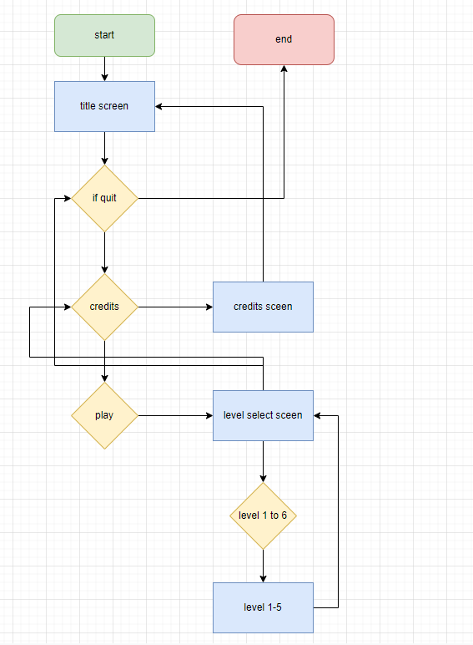

## 2.5. Look and Feel

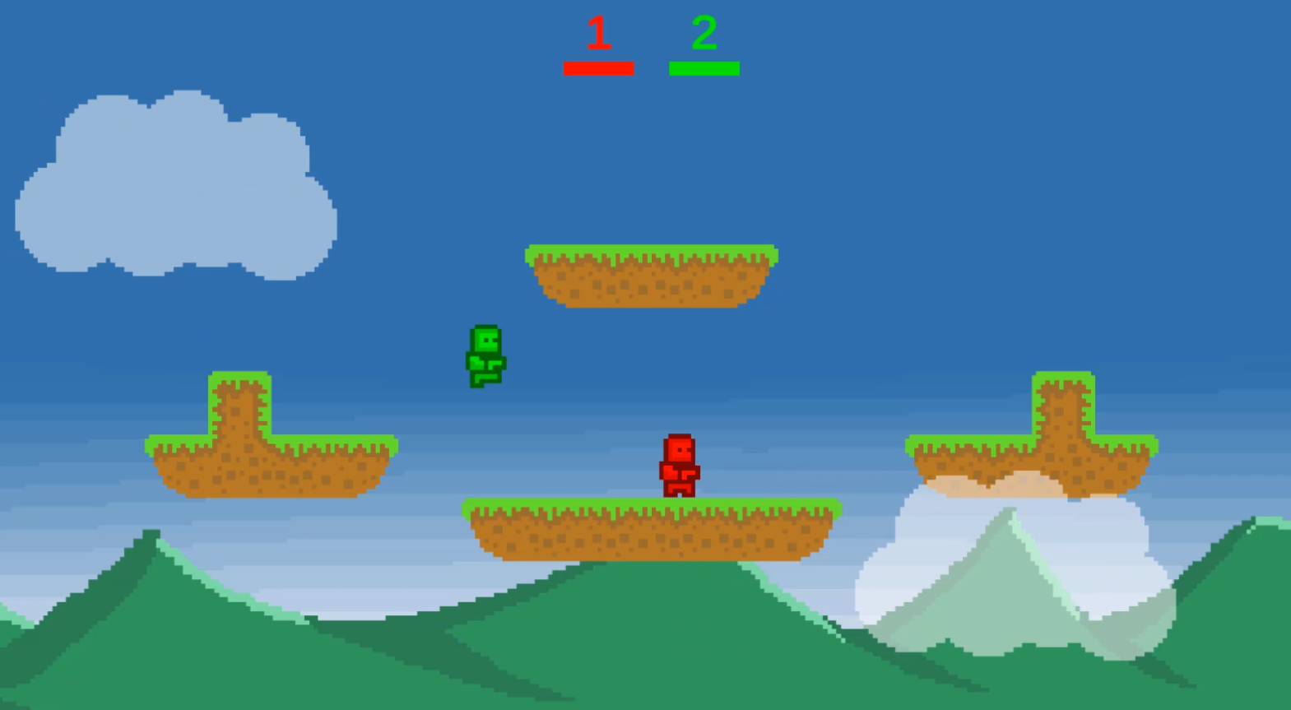

# 3. Gameplay

## 3.1. Objectives

Survive till the end of the round by Killing the other players befor they kill you

## 3.2. Game Progression

Level selection and Timed rounds

## 3.3. Play Flow

Players will spawn in to a zone in a random location and attack any other player in the zone by throwing fireballs at them if a players health hits 0 they die and the player that killed them gets a point the round will play for about 2 min at which point the person with the most points wins and the player is taken back to select a new level

## 3.4. Mission/Challenge Structure

Survival / PVP

## 3.5. Puzzle Structure

na

# 4. Mechanics

## 4.1. Rules

If a player falls off the screen they die and points will be taken away

If they are hit by a fireball they take damage

If health hit 0 the player dies

If your fireball kills the player the person who fired the fireball will get the point

The player can jump up to 3 times before touching the ground

## 4.2. Model of Game Universe

## 4.3. Physics

Basic rigidbody 2d physics

## 4.4. Economy

Score when killing a player

## 4.5. Character Movement

The players need to be able to move Left and right

## 4.6. Objects

tbd

## 4.7. Actions

Jump, attack, taunt, move

## 4.8. Combat

Shoot fireballs across the screen horizontally

## 4.9. Screen Flow

The Player chooses what level to play on

## 4.10. Game Options

na

## 4.11. Replaying and Saving

na

## 4.12. Cheats and Easter Eggs

na

# 5. Story and Narrative

## 5.1. Back Story

Skipping this section

## 5.2. Plot Elements

Skipping this section

## 5.3. Game Story Progression

Skipping this section

## 5.4. Cut Scenes

Skipping this section

# 6. Game World

## 6.1. General Look and Feel of World

How would you describe the general look and feel of the overall world you want the player to experience

## 6.2. Areas

Must have 5 different Areas

### 6.2.1. General Description and Physical Characteristics

What is it going to look like

If water level movement is slowed by x amount

If space gravity switches

### 6.2.2. Relation to the rest of the world

Where would this be located and how does it relate to the rest of the world

#### 6.2.2.1 Levels

Are there individual levels in this area and if so describe them

#### 6.2.2.2. Connections to other areas

What other areas does it connect to and how dose this level help you advance to the other levels

# 7. Characters

## 7.1. Character Descriptions (One for each Character)

### 7.1.1. Character 1

#### 7.1.1.1. Back Story

#### 7.1.1.2. Personality

#### 7.1.1.3. Appearance

#### 7.1.1.4. Abilities

#### 7.1.1.5. Relevance to the Story

#### 7.1.1.6. Relationship to Other Characters

### 7.1.2. Character 2

#### 7.1.2.1. Back Story

#### 7.1.2.2. Personality

#### 7.1.2.3. Appearance

#### 7.1.2.4. Abilities

#### 7.1.2.5. Relevance to the Story

#### 7.1.2.6. Relationship to Other Characters

## 7.2. Artificial Intelligence Use in Opponent and Enemy

na

## 7.3. Non-Combat and Friendly Characters

na

# 8. Levels

## 8.1. Training Level

## 8.2. Levels (One for each level)

### 8.2.1. Level 1

#### 8.2.1.1. Synopsis

#### 8.2.1.2. Required Introductory Material and how it is Provided

#### 8.2.1.3. Objectives

#### 8.2.1.4. Details of what Happens in the Level

##### 8.2.1.4.1. Map

##### 8.2.1.4.2. Critical path that the player needs to take

##### 8.2.1.4.3. Important and Incidental Encounters

##### 

# 9. Interface

## 9.1. Visual System

### 9.1.1. HUD

### 9.1.2. Menus

### 9.1.3. Camera Model

## 9.2. Control System

## 9.3. Audio, Music, and Sound Effects

## 9.4. Game Art (Art Style)

## 9.5. Help System